Multi-Sensor System for Improving the Reliability of Drone Flight

Se-il Park* · Jong-wook Jang**

*Department computer engineering of Dong-Eui University
176, Eomgwang-ro, Busanjin-gu
Busan, Korea
E-mail : zizidec@naver.com, Jwjang@deu.ac.kr

Abstract

In view of the possibility that a drone accident may result in casualties and property damages since it flies over the sky, a drone requires high hardware reliability enabling accurate controls under any circumstances. The core of drone control is to keep the airframe’s balance in any changes of external environment while flying so as to prevent unstable flight or crashes from happening. In order to improve the reliability of drone flight, this thesis has designed a system: (i) it is installed with double inertial measurement units to keep the airframe’s balance; (ii) it handles the sensor values of the two inertial measurement units twice; and (iii) it judges the airframe’s stability by use of a vibration detection sensor. The purpose of the design is to avoid any accidents attributable to malfunction in the inertial measurement unit or errors in delivered values, as one of the causes of drone accidents.

Keywords
Drone, Double Inertial Measurement Units, Vibration Detection, Control, Stability

I. Introduction

As the use of drones has increased in recent years, the relevant studies have been conducted in various areas including military services, industries, private services, etc. However, such increase in the use of drones has also led to increase in accidents every year. Pilot’s negligence, airframe’s defects and communication failure have been known as the main causes of such accidents.[1].
This thesis installs and uses double inertial measurement units, not a single, the core to prevent crashes and control flight by keeping the airframe’s balance, in order to prevent any drone accidents attributable to the airframe’s defects. Therefore, this thesis is to propose a system preventing drone crashes and accidents by flexibly responding to numerous hazardous situations while flying in relation to malfunction in inertial measurement units and failure in communication with the system by way of dually receiving the six values corresponding to the triaxis of acceleration and that of Gyro in the drone’s airframe and using such values according to its needs and additionally, installing a vibration detection sensor in the airframe.

II. Structure of the Inertial Measurement Unit

A drone is installed with double Inertial Measurement Units(IMU) and the triaxis values of acceleration (X_Accel, Y_Accel, and Z_Accel) and the triaxis values of Gyro (X_Gyro, Y_Gryo and Z_Gyro) are described as analog values. Such values are delivered to the system through an analog-digital converter.[2].
The triaxis of acceleration recognizes the airframe’s lateral inclination degree from its face as X_Accel(Roll), the anteroposterior inclination degree as Y_Accel(Pitch), and the horizontal rotation as Z_Accel(Yaw).
The Gyro triaxis represents X_Gyro if revolving around X_Accel, Y_Gyro if revolving around Y_Accel and Z_Gyro if revolving around Z_Accel.[3].

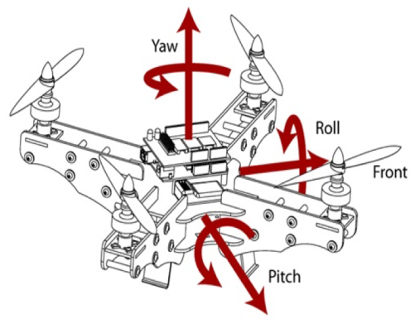
Fig 1. IMU Installed on a Drone

According to the foregoing fundamental principles of the acceleration triaxis and the Gyro triaxis, two inertial measurement units are located inversely on a Z(YAW) basis and installed on a drone, as can be seen in the below figure.

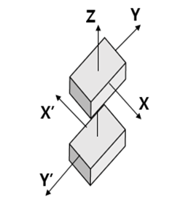
Fig 2. Structure of Double IMU

Basically, the system keeps the airframe’s balance according to the triaxis values of acceleration and Gyro from the forward inertial measurement unit and receives the opposite values of X'_Accel and Y'_Accel from the opposit inertial measurement unit. Since the inertial measurement units are structured inversely based on the Z axis, X_Accel and X'_Accel, Y_Accel and Y'_Accel present the opposite values to each other, respectively.

Table 1
Test Values of Double IMU

10 times Avg | A_Position | B_Position | C_Position
X_Accel | 16688 | 1880 | 12212
X’_Accel | -16068 | -1616 | -11900
Sum1 | 620 | 264 | 312
Y_Accel | -644 | 16280 | -234
Y’_Accel | 508 | -16320 | 296
Sum2 | -136 | -40 | 60

Table 1 shows the average of values which were measured 10 times in three random positions.
The test results of the two inertial measurement units which are located inversely may have some errors, depending on the existence of perfectly horizontal installment. However, the sum of X axes values or that of Y axes values from the two inertial measurement units converges to zero.

III. Design of Double Inertial Measurement Unit System

The drone system presented in this thesis utilizes the feature where the sum of the X axes values and that of the Y axes converge to zero since the two inertial measurement units are in inverse proportion to each other. Therefore, if the sum of the X axes values and that of the Y axes values from the two inertial measurement units fail to converge to zero or if the two values of Z axes increase or decrease in parallel, it is possible to judge that malfunction exists in the inertial measurement units while the drone flies or that errors are constantly found in the values delivered to the system.

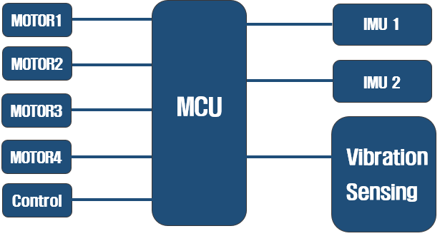
Fig 3. System Structure

Figure 3 shows the structure of the system where two inertial measurement units and a vibration detection sensor are installed unlike the other existing drone systems.

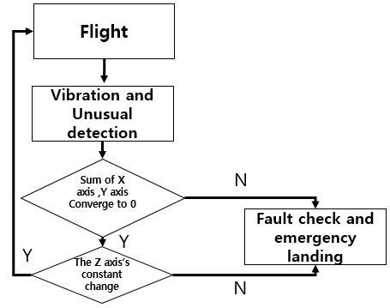
Fig 4. System Algorithm

If any errors are detected in the airframe through the foregoing algorithm based on the warning of the vibration detection sensor and the pilot’s judgment while a drone flies, the system prevents any accidents of unmanned aerial vehicles from happening by way of alternative operation and emergency landing after judging whether there are any errors in the device on the basis of the values from the double inertial measurement units.
When the forward inertial measurement unit is broken, an emergency landing can be made simply by putting in the opposite measurement such as using the negative if the values for X and Y are positive and vice versa.[4].

IV. Conclusion

This thesis has designed a system using double inertial measurement units which are located inversely and a vibration detection sensor in order to inform the pilot of any danger of crash or accident caused by the malfunction of devices installed on a drone with the existing system using a single inertial measurement unit or errors in the values delivered to the system.
The double inertial measurement units where X and Y axes are located inversely on a Z basis have confirmed the existence of malfunction in the devices by getting values close to zero without big errors.
It is anticipated that the proposed thesis will contribute to the reliability and safety of drones by way of avoiding drone crashes or accidents attributable to the problem of the inertial measurement unit.

Acknowledgement

This thesis has been supported by the 2016 Human Resource Development Project for Leading New Local Business(201601700001) of National Research Foundation of Korea (Busan Techno Park-2015DB0160001)

References

[1] “Craig Whitlock”, 「WHEN DRONES FALL FROM SKY」, The Washington Post, June 20,2014.
[2] “Gi-Hoon Song”. Development of a Safe and Intuitively Controllable Drone. Collection of Papers from KIISE Conferences 1817-1819. June, 2015.
[3] “Hyun-Soo Yang and Dong-Joon Lee”. Basic of Controlling Drone Flight and Assuming the State. Academic Journal of KIICE (Information and Communications), 33(2), 86-92. January, 2016.
[4] “Eun-Hee Noh, Kyung-Joo Gwon, Min-Gyu Kim, Won-Bin Lee and Yoon-Seok Go”. Study on Production of a Quadcopter based on PID Control System. Academic Journal of the Korea Institute of Electronic Communication Sciences, 8(1), 278-282.s, June, 2014.

